**Software Description (Server Side)**

Title: **Data Visualization and Analysis**

After we collected personal user data from user’s smartphone, we need to analyze and visualize it. So, this application created to solve that problem. We use R language to preprocessing, processing, and analysis personal user data.

Traditional tools for data analysis such as matlab, R, SPSS and etc, only support for plotting the result such as in figure with (jpeg, jpg, png) format and pdf. When we need generate document report or maybe want to expose the result in web, we have to copy the result to the web. The problem is when the data changed, we need to plot again and copy again to our document report or to the web. This application solve that problem. We use shiny library from R studio which can support to generate reproducible result for research with beautiful, interactive and responsive web layout.

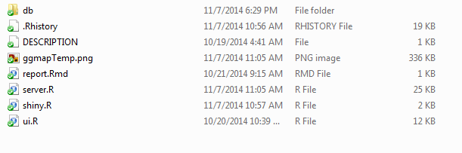

Figure 1. List of files of this framework

This application contain three main files: ui.R, server.R, and shiny.R.

1. ui.R is file that contain script to manage ui and layout of shiny application. The number of code is 202 lines with size 12 KB.
2. server.R is file that contain main script for loading, preprocessing, processing, and analysis the data, script using R language. Actually, This file contain many of functions, I just put all of functions in one file. The number of code in this file is 547 lines with size 25 KB.
3. shiny.R is config file, such as the user key, and about application configuration. This file only contain 37 lines with size 1 KB.
4. Report.Rmd this is just an example of Rmarkdown report. By using this file we can download file from plotting result (ex: regression plot) in many format such as PDF, HTML, and DOCX. The important thing is the file contain R source code and the result, so users who download that result plot they can see the source code and when they try that code in R environment will get same result. So, usually researcher call it “reproducible sample”.

The user data that we collected can be copy to folder ‘*db*’. To start this application, we need to go to parent directory before ‘*datalog’* directory. Directory ‘*datalog’* means the name of this application.

To start this application using this command:

runApp("datalog",display.mode = "showcase")

Actually the purpose for creating this application is to running in server (Shiny server), but for the example, we also can run this application in desktop environment. See the video demo_example.mov in this directory. To run this application we need some software requirements, on the next page we explain about how to setup environment in Ubuntu 12.04 or later.

Example Layout of this application.

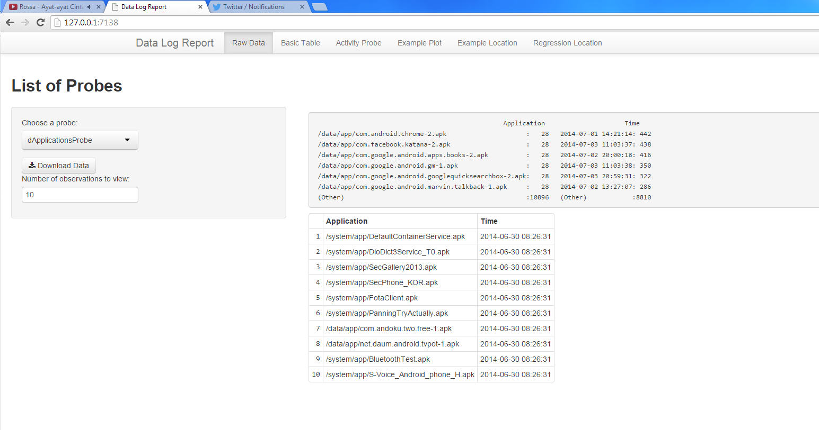

Figure 2. Example plot of user data log (Installed Application in User’s smartphone)

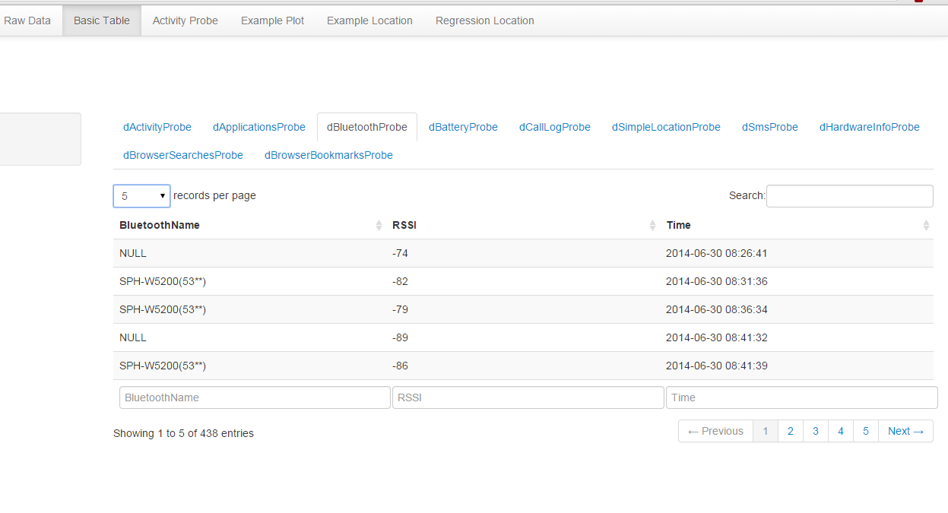

Figure 3. Different layout to show the data (Nearby Bluetooth data)

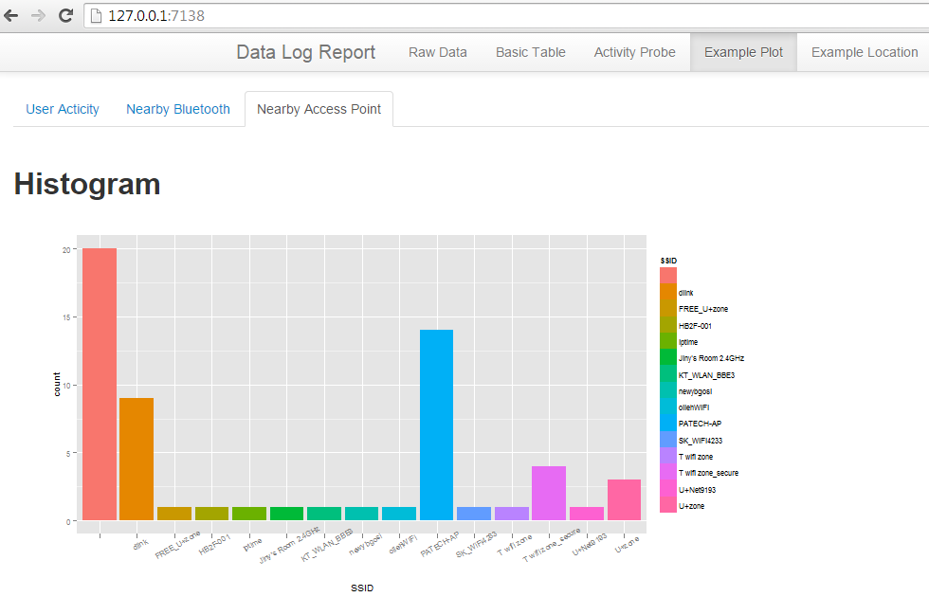

Figure 4. Example plot of Nearby Access Point

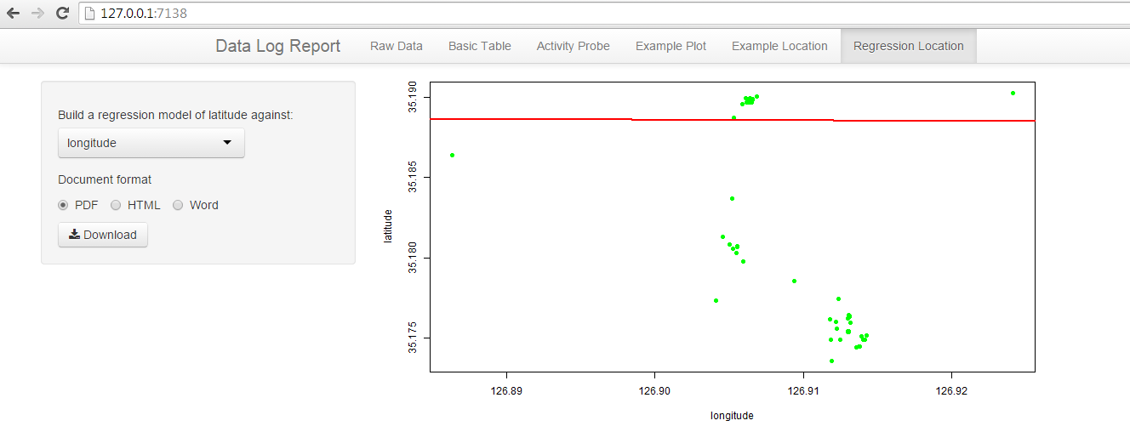

Figure 5. An Example of regression plot that can be download for reproducible research

**Setup and Installation**

Because of this application is for server side purpose, and to run this application, we have to setup and configure the environment. In this page, we explain about how to setup environment that can be used to run our framework.

OS requirement: **Ubuntu 12.04 or later**

Shiny Server, Currently only available for a pre-built binary for the 64-bit architecture. Running on other architectures will require building from source. Before installing Shiny Server, you’ll need to install R and the Shiny package. To install the latest version of R you should first add the CRAN repository to your system.

You can then install R using the following command:

$ sudo apt-get install r-base

NOTE: if you do not add the CRAN Debian in your Ubuntu repository this command will install the version of R corresponding to your current system version. Since this version of R may be a year or two old it is strongly recommended that you add the CRAN repositories so you can run the most up to date version of R. You’ll also need to install the Shiny R package before installing Shiny Server:

$ sudo su - \

-c "R -e \"install.packages('shiny', repos='http://cran.rstudio.com/')\""

Once you’ve installed R and the Shiny package, execute the following commands in a terminal window to install *gdebi* (which is used to install Shiny Server and all of its dependencies) and Shiny Server.

$ sudo apt-get install gdebi-core

$ wget http://download3.rstudio.org/ubuntu-12.04/x86_64/shiny-server-1.2.3.368-amd64.deb

$ sudo gdebi shiny-server-1.2.3.368-amd64.deb

Next Steps

Once installed, view the [Administrator’s Guide](http://rstudio.github.io/shiny-server/latest/) to learn how to manage and configure Shiny Server.

**R library needed:**

1. library(shinyapps)
2. library(shiny)
3. library(shiny)
4. library("RSQLite")
5. library("rjson")
6. library("ggplot2")
7. library("scales")
8. library("ggmap")
9. library("rmarkdown")
10. library("rmarkdown")

After the environment is ready, enter to R console and then run this command:

runApp("datalog",display.mode = "showcase")

Actually, total data that we collected from 48 participants is around 28 GB, but in this application we just put only few data for sample. If we want to add user data, just put it into folder ‘*db*’. For more details or If you want to implement in Desktop environment (using Rstudio), you can see the video demo_example.mov in this directory.

Thank you,